## The Earswitch: Basic Demo Set-up:

## Hardware:

1. 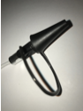Otoscope:

Original Setup:

(Available versions rapidly vary; following is currently available on Amazon UK: 30.3.2021)

“USB Otoscope-Ear Scope Camera, DEPSTECH 3.9mm Thin Lens, HD Visual Ear Pro Ear Endoscope for Adults and Kids, 6 Adjustable LED Ear Endoscope with Earwax Cleaning Tool for Android and Windows/Mac PC”

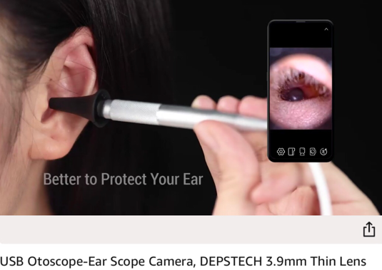

https://www.amazon.co.uk/gp/product/B08KT5NQ9D/

IF needed:

Earhook Ear Hook Loop Earloop Clip For Bluetooth Headset

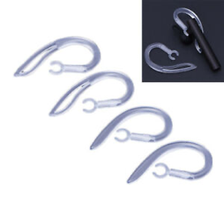 <https://www.ebay.co.uk/itm/5-6-7-8-9-10mm-Clear-Bluetooth-Earphone-Silicone-Earbud-Ear-hook-Loop-Clip-JE/353083578871>

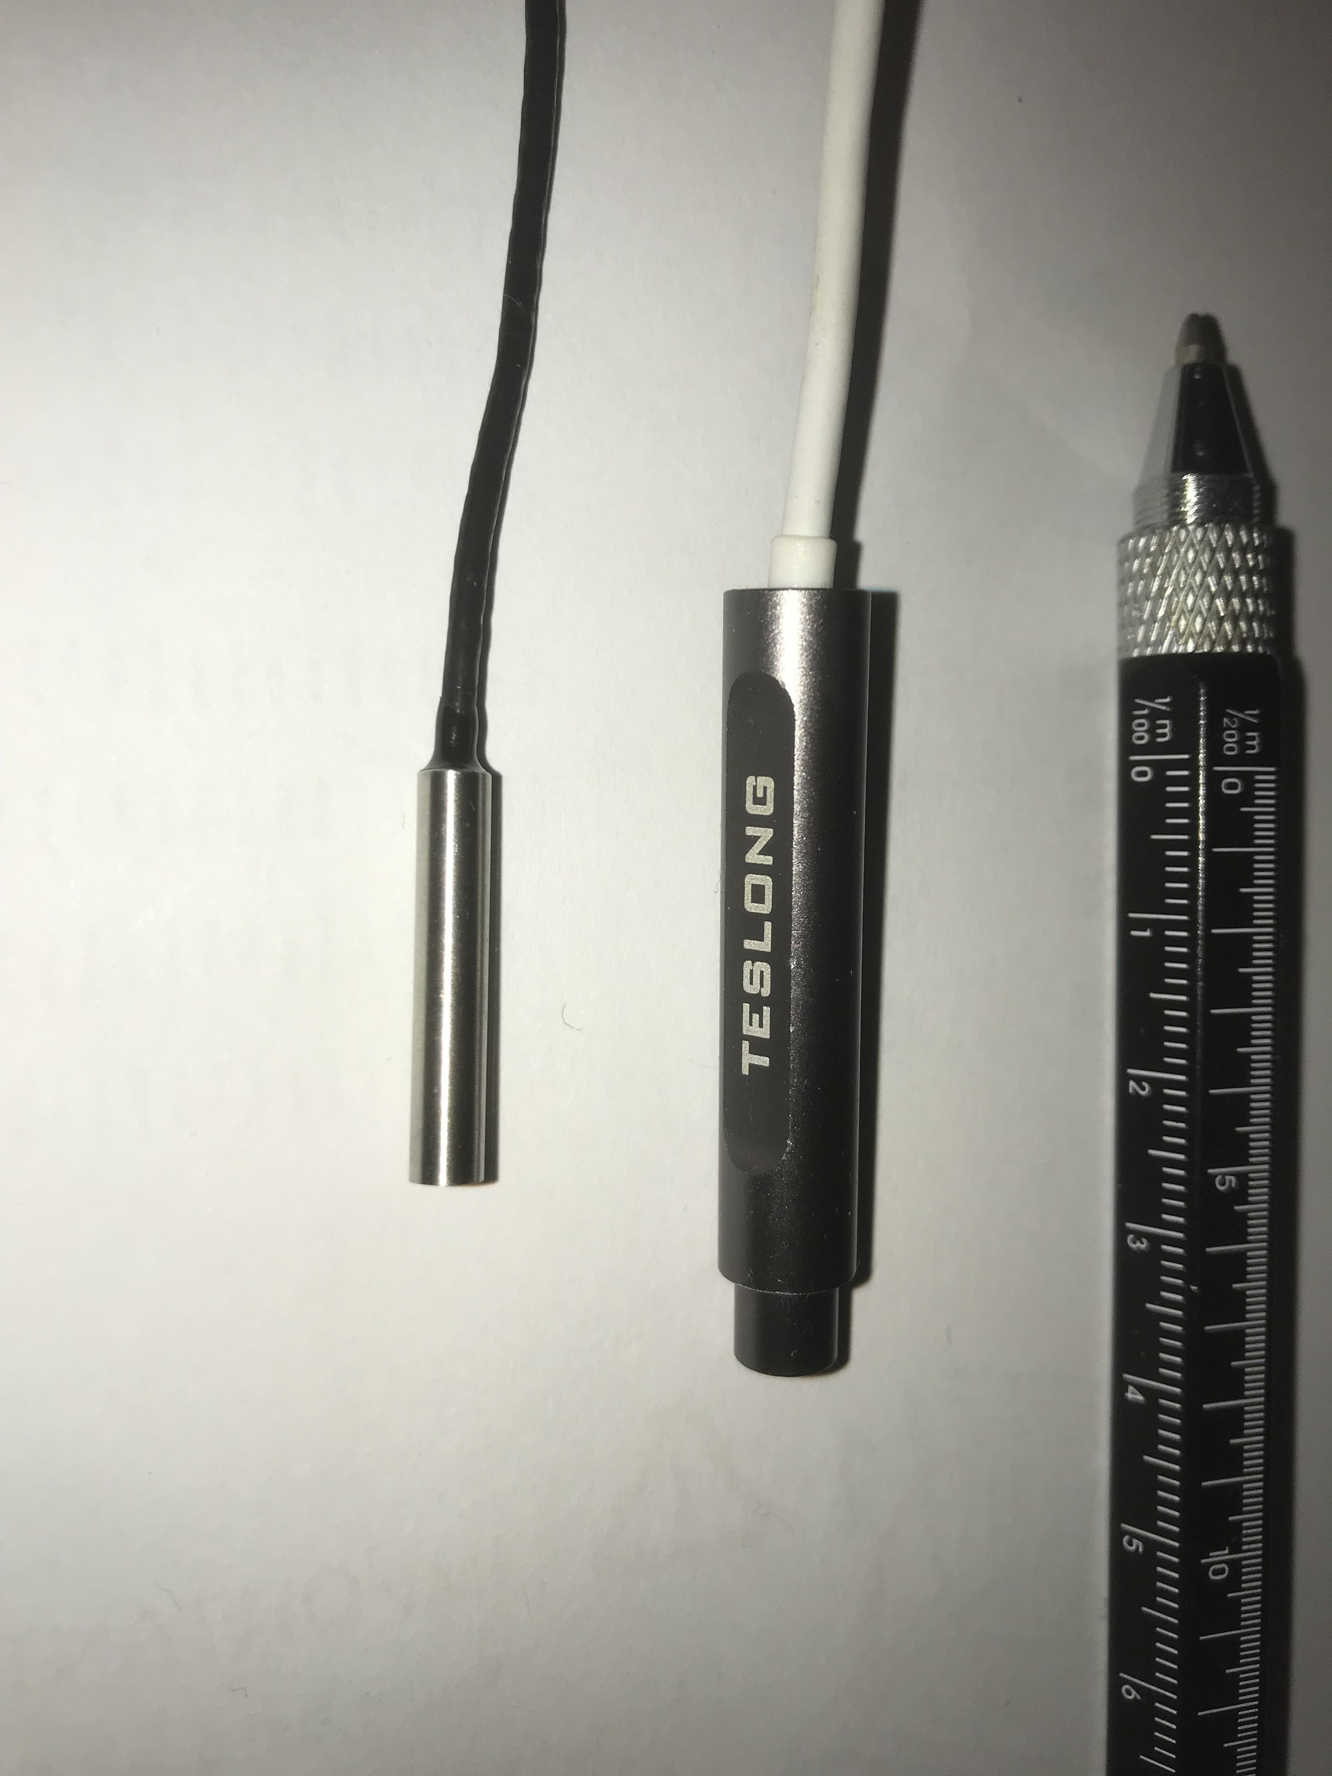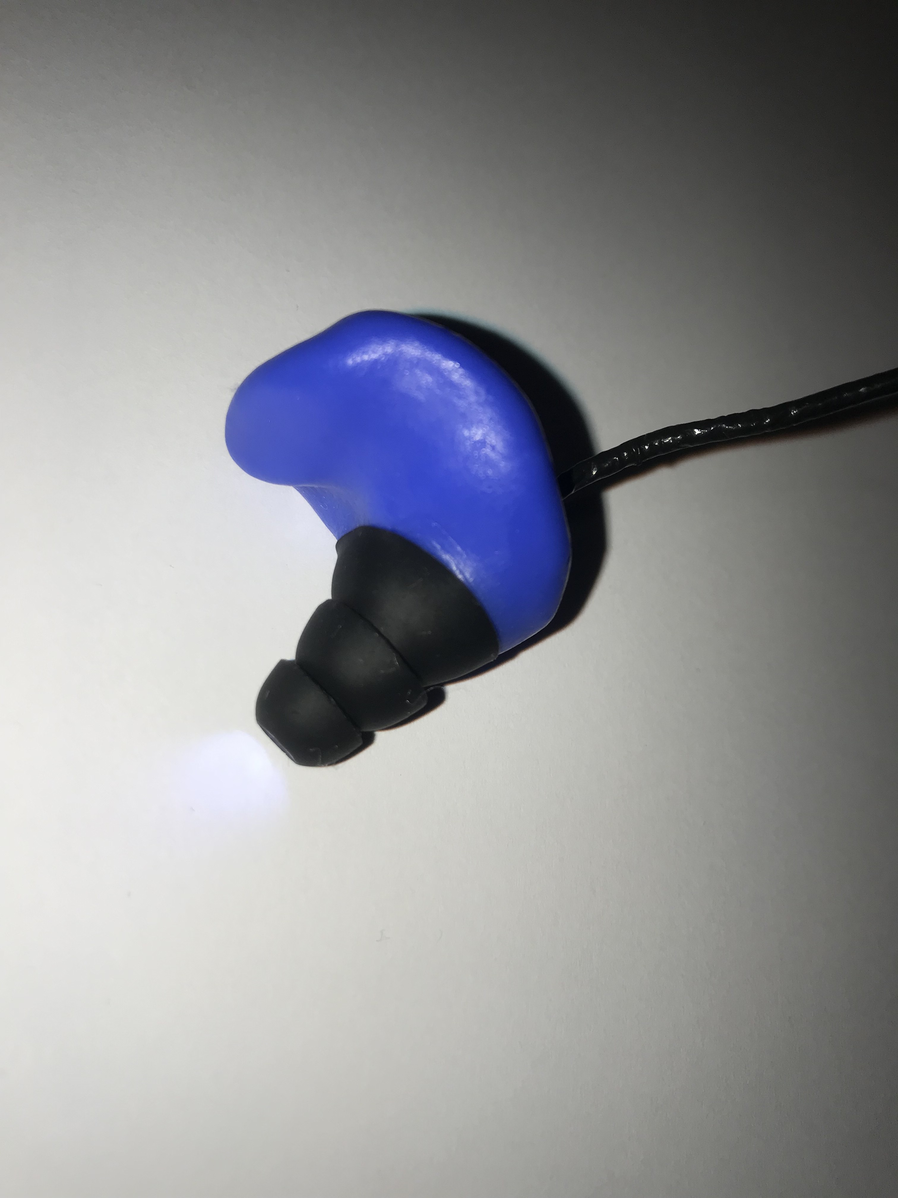 Example prototype using smaller otoscope modules:

1. Video movement of the ear-drum as you “ear-rumble”:

Example of expected movement:

https://www.dropbox.com/s/p5virpy2dm73ih3/Video%20of%20eardrum%20and%20intentional%20TT%20contraction.mp4?dl=0

## Demonstrating Control of Software with “Ear-rumbling:

Download the following program it allows the ear-drum movement to control the keyboard:

﻿ <https://sourceforge.net/projects/sviacam/>

Demonstration interfaces:

Either

1. Target practice : Open the “ScanningWizard” webpage : <https://www.scanningwizard.com/-> > chose “one switch set up”

Example video :

https://www.dropbox.com/s/10qtrtksve2m60v/The%20Earswitch%20Demonstration%20Video%207.6.2020.MOV?dl=0

OR

1. Typing on Virtual Keyboard

Example video:

https://www.dropbox.com/s/10qtrtksve2m60v/The%20Earswitch%20Demonstration%20Video%207.6.2020.MOV?dl=0

Open Microsoft “On-Screen Keyboard” ( present on Windows PCs)

can Search for it on the search bar next to Windows icon bottom left

Select-> Options

->Scan through keys: Speed 1.5 secs

-> Use keyboard  key; F12

-> Use Text Prediction

->Insert Space after predicted words

Open SwitchViaCam as Administrator (Right Click and click on “Run as Administrator”)- this allows SwitchViaCam to run as a background Window. If you can’t run as Administrator then just double-click to open; will need SwitchViaCam window to be running in the foreground

See the screenshot below:

Plug in the USB Otoscope

Click (top line)

Configuration> Selected Camera-> USB Otoscope Camera (needs to be plugged in)

If SwitchViaCam crashes then unplug otoscope

May need to adjust; Camera Properties for the PC webcam to: e.g.

Format 640x480

Capture Speed 5

& then plug in the USB Otoscope and restart SwitchViaCam & select the Otoscope under the Configuration Menu

Sensor 1 (blue)

Select: Advanced

Alter:

Motion Detection Threshold -> try 0.044 (drag slider)

(May need to be altered to get required sensitivity)

Put Otoscope into ear:

Sensor 1-> Enable Sensor - select box

Drag and expand selection box (blue box) to cover most of the middle of the eardrum image (will be shown in the black box shown here)

Change  “Event type” ->F12

Alter

Time Filter -> try 488ms (drag slider)

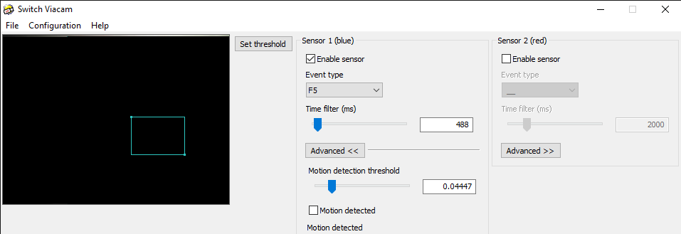

Either:

1. Target Practice

Open “Scanning Wizard” website

OR

1. Typing on virtual keyboard

Open: Word (Reduce the size of the Word Window: not minimise- so you can still see the image of your ear-drum)

Then when you move the eardrum it should start scanning sequential rows on the keyboard

Once on the correct row “Earclick” to select & it scans across the row

“Earclick” the group of letters to select

“Earclick” once the letter of interested is highlighted

Nick Gompertz

www.earswitch.co.uk

30.3.2021